CSE4204 | Section A2 | Computer Graphics Lab | Assignment – 2

[10 marks] Part A: Create a 2D flower based on Rhodonea curve. Use GL_POINTS in your draw call. For each click, the arrangement of the petals will keep changing. Also, the color of the points will be alternated between green and red for each click. Note that, you have to send 2D data to the shader from CPU.
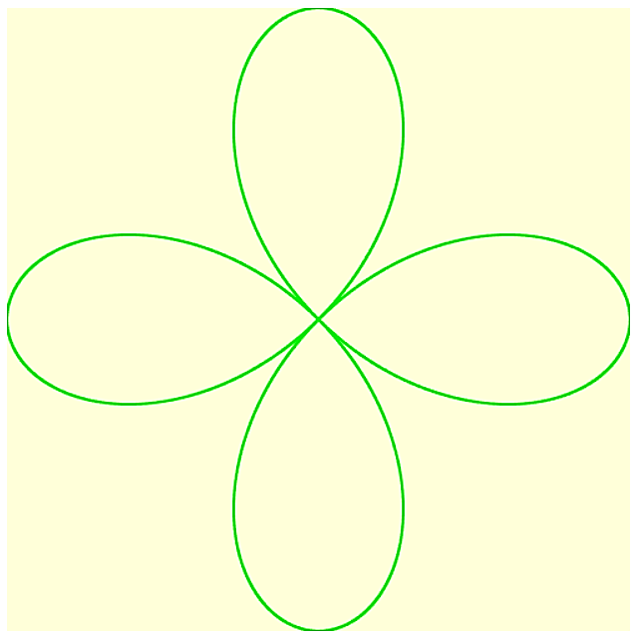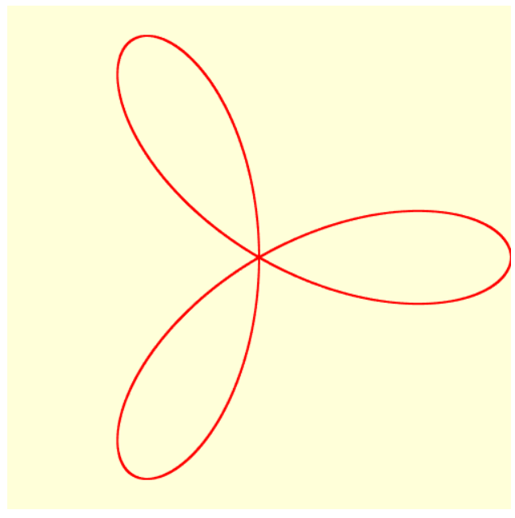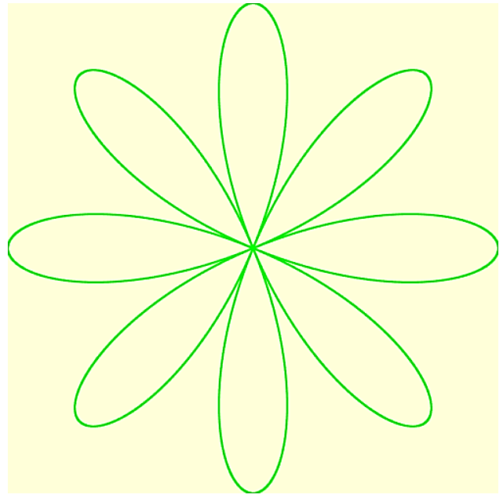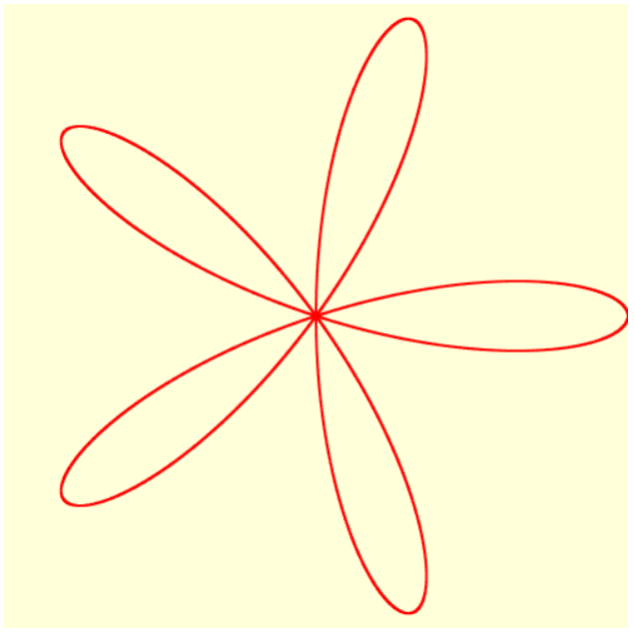
Figure: Situation of the canvas after several mouse clicking (from left to right).
See video: https://rb.gy/ea0yi9
Hints:
- Rose in math: https://en.wikipedia.org/wiki/Rose_(mathematics)
- You can track odd/ even clicking in the shader to alternate color.
- To generate the vertices for a 2D spiral in CPU, you can use JavaScript’s Math library to apply the formula, e.g. Math.cos(). Use push() function to build up an array of vertices of the spiral using a loop.
- Appy optimistically while using/ reusing vertex buffer.

[10 marks] Part B: Create a 2D scenario (model) using your creativity. The model has to be created using 2D triangle mesh. Apply per-vertex color on your model. Integrate a keyboard interaction having at least one GLSL control statement (and/or built-in function) inside the shader.
Note:
- Your mesh must have at least 45 vertices in total.
- You can use gl.TRIANGLES and/or gl.TRIANGLE_STRIP and/or gl.TRIANGLE_FAN.

Submission Process: You have to follow the coding skeleton provided during the sessional class. Rename your file like this: yourID_PartA.html, yourID_PartB.html. Submission is open until the day before the next sessional class.

